"Assessing the Impact of Outlier Removal on Churn Prediction Model Performance: Implications for Data Quality and Predictive Accuracy"
Jen T Sengbe
Data Cleaning
December 1, 2024

Question or Decision
My research question is: "What is the impact of outlier removal on the performance of churn prediction models?" My inquiry focuses on data quality and outlier detection and removal. Outlier detection and removal are important because outliers can have a significant impact on data and may produce skewed data which can affect model performance. Therefore, understanding how to remove or handle outliers that influence data quality is important.
Observing and evaluating the results of outlier removal on various churn prediction models—such as accuracy and precision—provides insights into the effectiveness of said models. My query will help evaluate and determine whether outlier removal enhances the reliability of churn predictions. My research question also highlights the importance of data quality and its impact on predictive modeling. Improving churn prediction accuracy will allow telecommunications companies and stakeholders to make better-informed decisions regarding their marketing strategies, business development, and customer retention.
Required Variables
CaseOrder (Quantitative) this is an identifier for the order in which the data was collected. Examples from the dataset include: ‘1, ‘2, ‘3

Customer_id (Qualitative) this is a unique identifier for each customer. Examples from the dataset include: ‘aa90260b-4141-4a24-8e36-b04ce1f4f77b’, ‘fb76459f-c047-4a9d-8af9-e0f7d4ac2524’

Interaction (Qualitative) This variable represents the type of interaction or case a customer had. Examples from the dataset include: ‘K409198’ and ‘S120509’

City (Qualitative) This is the city where customers reside. Examples from the dataset include: ‘Point Baker’ and ‘West Branch’

State (Qualitative) This is the state where the customer resides. Examples from the dataset include: ‘AK’ and ‘MI.’

County (Qualitative) This is the county where the customer resides. Examples from the dataset include: ‘Prince of Wales-Hyder’ and ‘Ogemaw.’

Zip (Qualitative) This is the postal code of the customer’s residence. Examples from the dataset include: ‘99927’ and ‘48661.’

Lat (Quantitative) This is the latitude coordinate of the customer’s location. Examples from the dataset include: ’56.251’ and ’44.32893.’

Lng (Quantitative) This is the longitude coordinate of the customer’s location. Examples from the dataset include: ‘-133.37571’ and ‘-87.2408.’

Population (Quantitative) This describes the population of the city or area where the customer resides. Examples from the dataset include: ‘38’ and ‘10446.’

Area (Qualitative) This describes the type of area where the customer resides, such as Urban or Suburban. Examples from the dataset include: ‘Urban’ and ‘Suburban.’

Timezone (Qualitative) This describes the time zone of the customer’s location. Examples from the dataset include: ‘America/Sitka’ and ‘America/Detroit.’

Job (Qualitative) This describes the job title or occupation of the customer. Examples from the dataset include: ‘Environmental health practitioner’ and ‘Programmer multimedia.”

Children (Quantitative) This variable shows the number of children the customer has. Examples from the dataset include: ‘1’ and ‘3.’

Age (Quantitative) This variable describes the age of the customer. Examples from the dataset include: ‘68’ and ’27.’

Education (Qualitative) This variable shows the highest level of education achieved by the customer. Examples from the dataset include: ‘Master’s Degree’ and ‘Regular High School Diploma.’

Employment (Qualitative) This variable shows the employment status of the customer. Examples from the dataset include: ‘Part Time’ and ‘Retired.’

Income (Quantitative) This variable describes the annual income of the customer. Examples from the dataset include: ‘28561.99’ and ‘21704.77.’

Marital (Qualitative) This variable describes the marital status of the customer. Examples from the dataset include: ‘Widowed’ and ‘Married.’

Gender (Qualitative) This variable describes the gender of the customer. Examples from the dataset include: ‘Male’ and ‘Female.’

Churn (Binary) This variable indicates whether the customer has churned (left the service) or not. Examples from the dataset include: ‘Yes’ and ‘No.’

Outage_sec_perweek (Quantitative) This variable shows the average number of seconds oer week the customer experiences outages. Examples from the dataset includes: ‘6.972566093’ and ’12.01454108.’

Email (Quantitative) This variable defines the number of emails the customer has received. Examples from the dataset include: ‘10’ and ’12.’

Contacts (Quantitative) This variable describes the number of contacts or interactions with customer service. Examples from the dataset include: ‘0’ and ‘2.’

Yearly_equip_failure (Quantitative) This variable describes the number of equipment failures the customer experienced per year. Examples from the dataset include: ‘0’ and ‘2.’

Techie (Binary) This variable describes whether the customer is considered tech-savvy or not. Examples from the dataset include: ‘No’ and ‘Yes.’

Contract (Qualitative) This variable describes the type of contract the customer has with the service provider. Examples from the dataset include: ‘One year’ and ‘Month-to-month.’

Port_modem (Binary) This variable describes whether the customer has a port modem or not. Examples from the dataset include: ‘Yes’ and ‘No.’

Tablet (Binary) This variable describes whether the customer has a tablet or not. Examples from the dataset include: ‘Yes’ and ‘No.’

InternetService (Qualitative) This variable describes the type of internet service the customer uses. Examples from the dataset includes: ‘Fiber Optic’ and ‘DSL.’

Phone (Binary) This variable describes whether the customer has phone service. Examples from dataset include: ‘Yes’ and ‘No.’

Multiple (Binary) This variable describes whether the has multiple lines or not. Examples from the dataset include: ‘Yes’ and ‘No.’

OnlineSecurity (Binary) This variable describes whether the customer has online security features. Examples from the dataset include: ‘Yes’ and ‘No.’

OnlineBackup (Binary) This variable describes whether the customer has online backup features. Examples from the dataset include: ‘Yes’ and ‘No.’

DeviceProtection (Binary) This variable describes whether the customer has device protection features. Examples from the dataset include: ‘Yes’ and ‘No.’

TechSupport (Binary) This variable describes whether the customer has tech support. Examples from the dataset include: ‘Yes’ and ‘No.’

StreamingTV (Binary) This variable describes whether the customer subscribes to streaming TV services. Examples from the dataset include: ‘Yes’ and ‘No.’

StreamingMovies (Binary) This variable describes whether the customer subscribes to streaming movies services. Examples from the dataset include: ‘Yes’ and ‘No.’

PaperlessBilling (Binary) This variable describes whether the customer uses paperless billing or not. Examples from the dataset include: ‘Yes’ and ‘No.’

PaymentMethod (Qualitative) This variable describes the method used by the customer to make payments. Examples from the dataset include: ‘Credit Card (automatic)’ and ‘Bank Transfer(automatic).’

Tenure (Quantitative) This variable describes the length of time (in years) the customer has been with the service. Examples from the dataset include: ‘6.795512947’ and ‘242.9480155.’

MonthlyCharge (Quantitative) This variable describes the monthly charge for the service the customer uses. Examples from the dataset include: ‘171.4497621’ and ‘242.9480155.’

Bandwidth_GB_Year (Quantitative) This variable describes the customer’s annual bandwidth usage in gigabyte. Examples from the dataset include: ‘904.5361102’ and ‘800.9827661.’

Item1(Quantitative) This variable is a survey response that describes on a scale from 1 to 8 (1 being most important and 8 being least important) how important timely responses are to the customer. Examples from the dataset include: ‘5’ and ‘3.’

Item2 (Quantitative) This variable is a survey response that describes on a scale from 1 to 8 (1 being most important and 8 being least important) how important timely fixes are to the customer. Examples from the dataset include: ‘5’ and ‘4.’

Item3 (Quantitative) This variable is a survey response that describes on a scale from 1 to 8 (1 being most important and 8 being least important) how important timely replacements are to the customer. Examples from the dataset include: ‘5’ and ‘3.’

Item4 (Quantitative) This variable is a survey response that describes on a scale from 1 to 8 (1 being most important and 8 being least important) how important reliability is to the customer. Examples from the dataset include: ‘3’ and ‘4.’

Item5 (Quantitative) This variable is a survey response that describes on a scale from 1 to 8 (1 being most important and 8 being least important) how important having options is to the customer. Examples from the dataset include: ‘4’ and ‘5.’

Item6 (Quantitative) This variable is a survey response that describes on a scale from 1 to 8 (1 being most important and 8 being least important) how important respectful responses are to the customer. Examples from the dataset include: ‘4’ and ‘3.’

Item7 (Quantitative) This variable is a survey response that describes on a scale from 1 to 8 (1 being most important and 8 being least important) how important courteous exchanges are to the customer. Examples from the dataset include: ‘3’ and ‘4.’

Item8 (Quantitative) This variable is a survey response that describes on a scale from 1 to 8 (1 being most important and 8 being least important) how important evidence of active listening is to the customer. Examples from the dataset include: ‘4’ and ‘3.’
Plan to Assess Quality of Data
To figure out how removing unusual data (outliers) affects predicting customer churn, I’ll follow a step-by-step process to assess the quality of the dataset. First, I’ll explore the data to understand what it’s about. I’ll load the dataset onto Google Colab using the df = pd.read_csv command to check out the variables related to customer churn. Next, I’ll check for missing values in the dataset and their percentages using the df.isnull() command. After that, I’ll check for duplicates in the data using the df.duplicated().sum() command. I’ll ask Google Colab to check and display information about the data types and non-null counts of the colums in the dataframe using the command: print(df.info()).
To further assess the quality of the dataset, I’ll use descriptive statistics for numeric columns using the df.describe() and print commands. That will allow me to check the mean, median, mode, standard deviations, and interquartile ranges of the dataset. I’ll also check for unique categorical columns using the df.select_dtypes().columns and df[col].nunique() commands. Finally, I’ll ask Google Colab to check for potential anomalies in numeric columns in the dataset and their minimum and maximum values using the df.select_dtypes() command.
.
Justification of Approach
My approach to assessing the dataset’s quality ensures it is suitable for predicting customer churn by addressing key data quality areas such as completeness, consistency, validity, accuracy, and reliability. Loading the dataset and exploring its variables provides an essential understanding of its structure, while checking for missing values and their percentages evaluates completeness, guiding decisions on handling missing data. Detecting duplicates eliminates redundant entries, ensuring consistency, and verifying data types and non-null counts highlights potential type mismatches that may affect validity. Descriptive statistics for numeric columns help identify outliers and anomalies while analyzing unique values in categorical columns ensures categories are well-defined and accurate. Finally, assessing minimum and maximum values addresses reliability by flagging potential anomalies that could distort predictions. This comprehensive process aligns with the dataset’s characteristics, ensuring it is clean, representative, and ready for accurate churn prediction modeling.
Justification of Tools
I’m using Python and its pandas library because they are very good at handling data and easy to use. Pandas is perfect for working with data in tables, which is what we’re dealing with in this project. It allows us to load data easily from files (like CSV or Excel) and check it out with simple commands (Larose C., Larose D., 2019). We can get a quick overview of the data using commands like describe() to see basic statistics or info() to check for missing values.
If we need to detect outliers, pandas works well with other Python libraries like NumPy and SciPy, which are good at math and statistics. These libraries help us calculate things like the Z-score and IQR to find outliers (Larose C., Larose D., 2019). Although pandas doesn't do fancy visualizations on its own, it works great with Matplotlib and Seaborn, two libraries that help us create graphs like box plots and scatter plots to spot outliers visually.
When it comes to cleaning the data, pandas makes it easy to either remove or fix bad data. We can use commands like drop() to remove outliers or apply() to change values (like taking the log of a number). For missing data, pandas has tools like fillna() to replace missing values or dropna() to delete rows with missing values (Larose C., Larose D., 2019).
Additionally, pandas works seamlessly with Scikit-Learn, which is another Python library used for machine learning. This makes it easy to train models on the data and test how well they perform. Scikit-Learn provides functions like train_test_split() to split the data into training and testing sets, and tools to measure the model's accuracy and precision (Larose C., Larose D., 2019). Finally, pandas helps us keep track of everything we’ve done by letting us create summary tables and export them to files like CSV or Excel.
Cleaning Findings
Upon assessing the data, I found a few issues that needed fixing. When assessing the descriptive statistics for numeric columns, the standard deviations for “CaseOrder (standard deviation: 2886.89568),” “Zip (standard deviation: 27532.196108),” “Lng (standard deviation: 15.156142),” “Population (standard deviation: 14432.698671),” “Age (standard deviation: 20.753928),” “Income (standard deviation: 28358.469482),” “MonthlyCharge (standard deviation: 174.076305),” “Outage_Sec_Perweek (standard deviation: 7.025921),” and “Bandwidth_GB_Year (standard deviation: 2187.396807),” columns indicated that data in those columns were spread out with some values being much higher or lower than the mean for each column. Those values being higher and lower than the mean can indicate outliers in the data set.
There were a total of 13906 missing values in the dataset. The columns “Children (2495/24.95% missing values),” “Age (2475/24.75% missing values),” “Income (2490/24.90% missing values),” “Techie (2477/24.77% missing values),” “Phone (1026/10.26% missing values),” “TechSupport (991/9.91% missing values),” “Tenure (931/9.31% missing values),” and “Bandwidth_GB_Year (1021/10.21% missing values),” were missing data. When checking for potential anomalies in numeric columns in the dataset, “Outage_Sec_Perweek (Min: -1.348571 & Max: 47.04928),” “Contacts (Min: 0 & Max: 7),” “Yearly_Equip_Failure (Min: 0 & Max: 6),” “Tenure (Min: 1.00025934 & Max: 71.99928),” “MonthlyCharge (Min: 77.50523 & Max: 315.8786),” “Email (Min: 1 & Max: 23),” and “Bandwidth_GB_Year (Min: 155.5067148 & Max: 7158.982),” were listed as columns that could potentially have anomalies. Although columns “CaseOrder,” “Zip,” “Lat,” “Lng” “Population,” “Age,” “Children,” “Income,” and Item1-Item8 were also listed as having potential anomalies, I left them untreated because it’s unnecessary to treat them; however, the issues mentioned above showed that the data needed some careful cleaning before we could use it for predictions.
Justification of Mitigation Methods
To fix these problems, I used different methods. To begin, I removed columns with at least 50% missing values using the df.drop() command to prevent unreliable and inaccurate results in the dataset. I then removed columns with duplicates using the df.drop_duplicates() command (of which there were none). I asked Google Colab to replace categorical data with missing values with the mode and numeric data with missing values with the median using the command: fillna() to create a more uniform dataset. After that, I asked Google Colab to define reasonable bounds in numeric columns by using the the df.select_dtypes() and quantile() commands to identify values in the dataset that are significantly different than the rest. Those significantly different values may signify errors that may skew results in the dataset even with cleaning. Finally, I asked Google Colab to standardize text formatting in the categorical columns using the df.select_dtypes(), str.lower(), and str.strip() commands for an easier read of the dataset and to prevent inconsistencies by reclassifying values to make everything more uniform.
Summary of the Outcomes
After preprocessing the data, the quality improved significantly. Removing columns with over 50% missing values and adjusting the outliers created a more balanced dataset. Imputing missing values with the median for numeric columns and mode for categorical columns minimized the potential of bias in subsequent modeling. Setting lower and upper bounds for numeric columns ensured the data adhered to fixed ranges, thus eliminating inconsistencies. Standardizing the text of categorical data helped format everything and created uniformity in the dataset. All of this resulted in a cleaner, more reliable dataset that’s ready for analysis and predictions.
Limitations
Although the cleaning process improved the data, there were some limitations. Decisions on handling outliers were not always straightforward and often required judgment. Choosing to leave some outliers without treatment was also a limitation. An excellent example of this was leaving columns “CaseOrder,” “Zip,” “Lat,” “Lng” “Population,” “Age,” “Children,” “Income,” and Item1-Item8 untreated when checking for anomalies in the dataset. Dropping columns missing half of their values could have significantly reduced the sample size of the dataset. Imputing missing values with the median for numeric values and the mode for categorical values might not perfectly match the actual data distribution. These limitations may cause some noise or small errors in the data despite my efforts to clean it up.
Impact of Limitations.
These limitations could affect the analysis by introducing bias or oversimplifying the dataset. For example, assumptions made during imputation might distort patterns in the data, while residual noise or missed outliers could reduce model performance. These issues might ultimately influence the ability to evaluate the impact of outlier removal on churn prediction models, as the cleaned dataset may not fully capture the complexity of the original data.
Mitigation Code
The annotated code I used for mitigating the data quality issues can be found in a separate attached file titled: D1.
Clean Data
A copy of my cleaned data set CSV file can be found in a separate attached file titled: D2 (W3Schools.com, n.d.).
Principal Components
I had six principal components. The loading matrix shows the contribution of each variable to the principal components and is provided below:
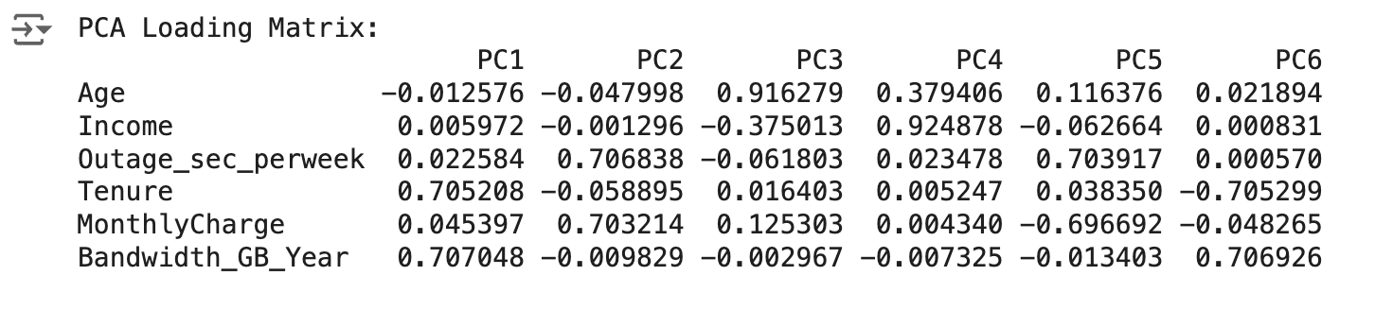
Criteria Used
I did not use the Kaiser Rule but opted for the explained variance approach to create my scree plot. After defining my continuous variables using the continuous_vars command, I started with six principal components and retained five to meet the 85% cumulative explained variance threshold I set. My decision to trade 15% of the variance may have reduced accuracy but improved the interpretability and computational efficiency of the large dataset. I identified the optimal count using a scree plot, which displays cumulative explained variance against the number of components. The plot's "elbow" point confirmed that retaining five components effectively captures the most significant variance while discarding the least important features.
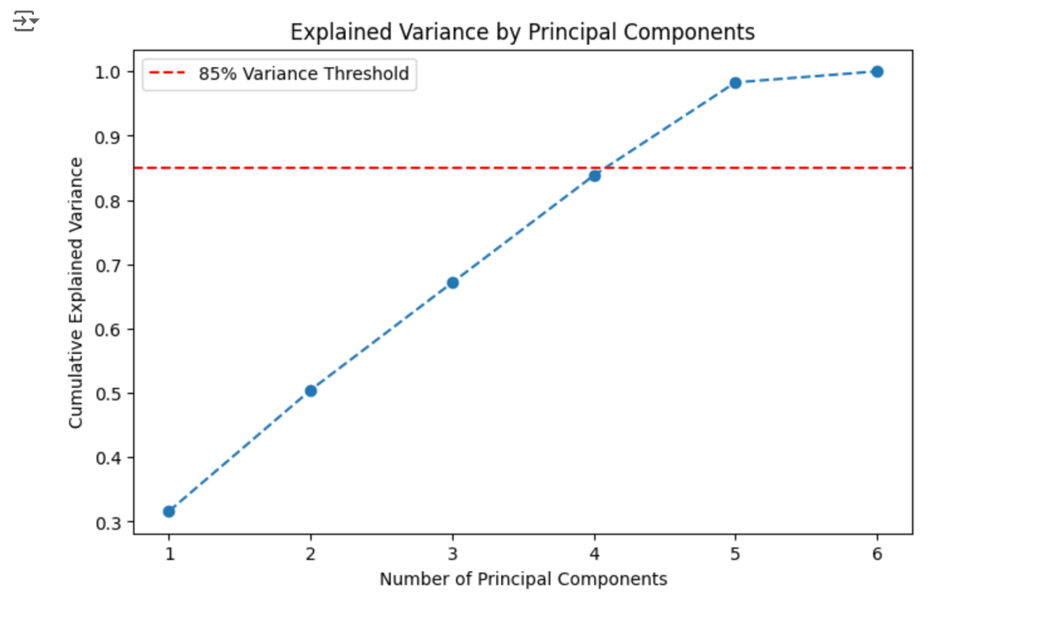
Benefits
Using PCA helps simplify the dataset without losing important information. It makes the data easier to analyze, speeds up computations, and improves the performance of predictive models. PCA also helps us identify the key factors driving customer behavior which can guide decision-making.

Sources of Third-Party Code
Chantal D. Larose, & Daniel T. Larose. (2019). Data Science Using Python and R. Wiley.
W3schools.com. (Editor / Interpreter). (n.d.). https://www.w3schools.com/python/python_compiler.asp

